***Video Game Trailer***

Sound/Script: Continued music builds up slowly

Action: continued gameplay with captions explaining How your complete tasks to get points

Sound/Script Continued music builds up slowly

Action: Transition to another animation. Where two clones of the builder shake hands

Sound/Script: Continued music builds up slowly

Action: The gameplay from the previous Time Stamp continues to the point where the ragdoll swings off screen again.

Timespan: 0:20 – 0:25

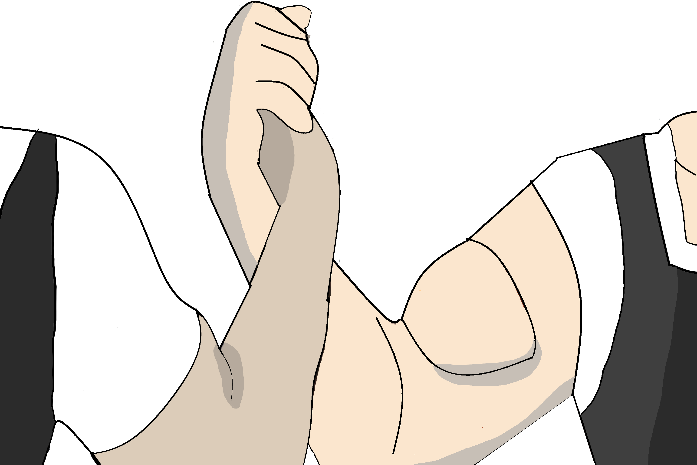

Timespan: 0:25 – 0:30

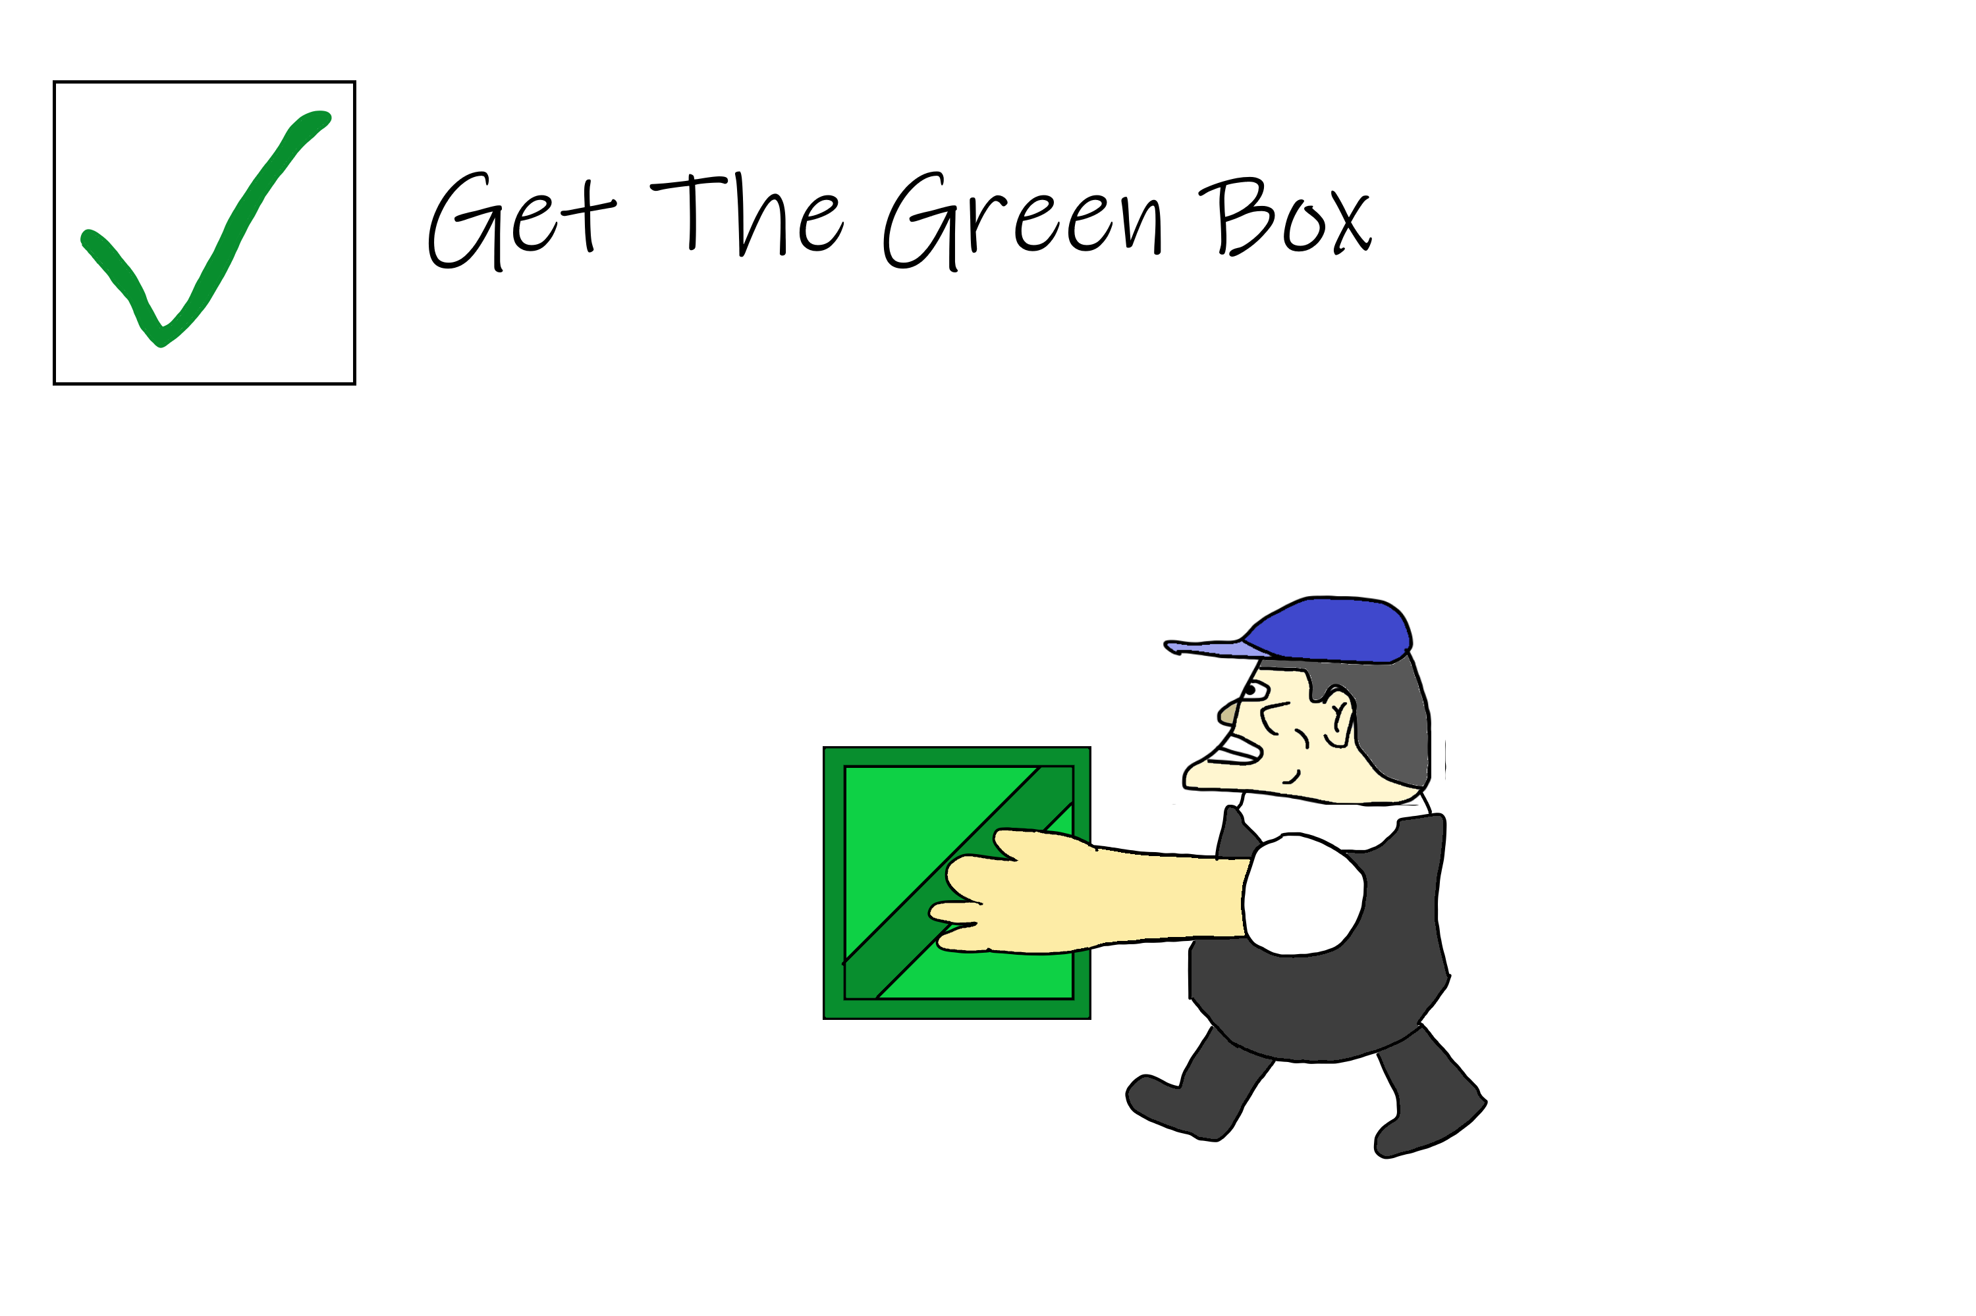

Sound/Script: Continued music followed by a glass smashing sound

Action: The gameplay from the previous Time Stamp continues to the point where the ragdoll swings off screen again.

Timespan: 0:15 – 0:20

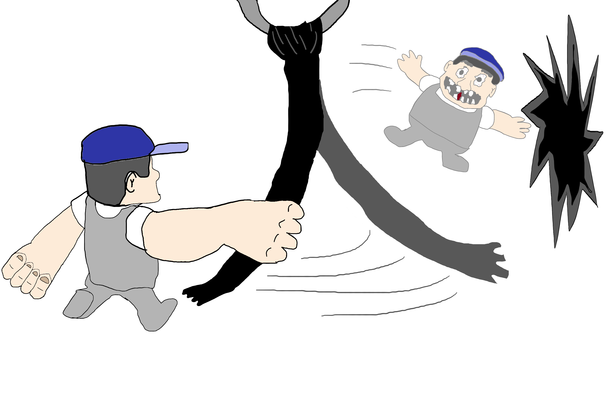

Action: The Ragdoll version of the sprite starts falling past the screen of some game play

Sound/Script: Start of Epic music for gameplay trailer

Sound/Script: Quite Walking on a stage sound followed with crash

Action: Main Character in Sprite form Walks across to the middle of the screen then a Concrete slab being held up by a crane snaps and lands on top of him

Timespan: 0:00 – 0:05

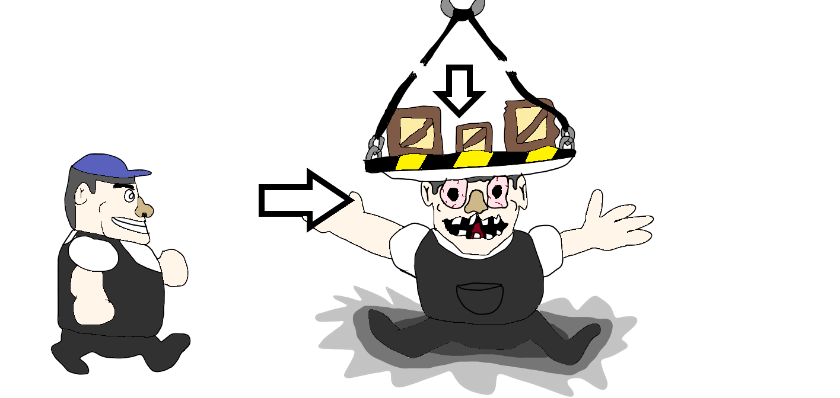

Timespan: 0:10 – 0:15

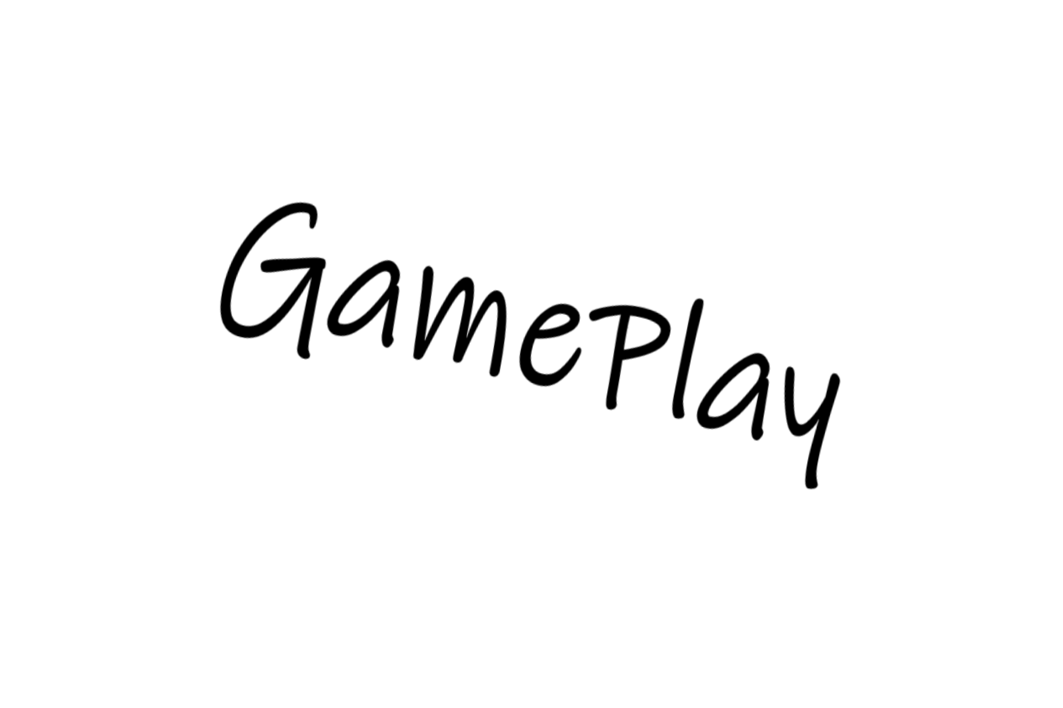

Timespan: 0:05 – 0:10

***Estimated Length: 1 Minute to 1 ¼ minutes***

***Storyboard***

***Video Game Trailer***

Sound/Script: Continue calmer piece

Action: Character is shocked and screams when ragdoll builds back together.

Sound/Script: Continue calmer piece

Action: Final animation plays showing character scratching his head next over a fallen apart ragdoll

Sound/Script: Cut Music then a calmer music piece place for the final 10 seconds

Action: Reveal Title of the Game in Nice Transition and Release Date

Timespan: 0:50 – 0:55

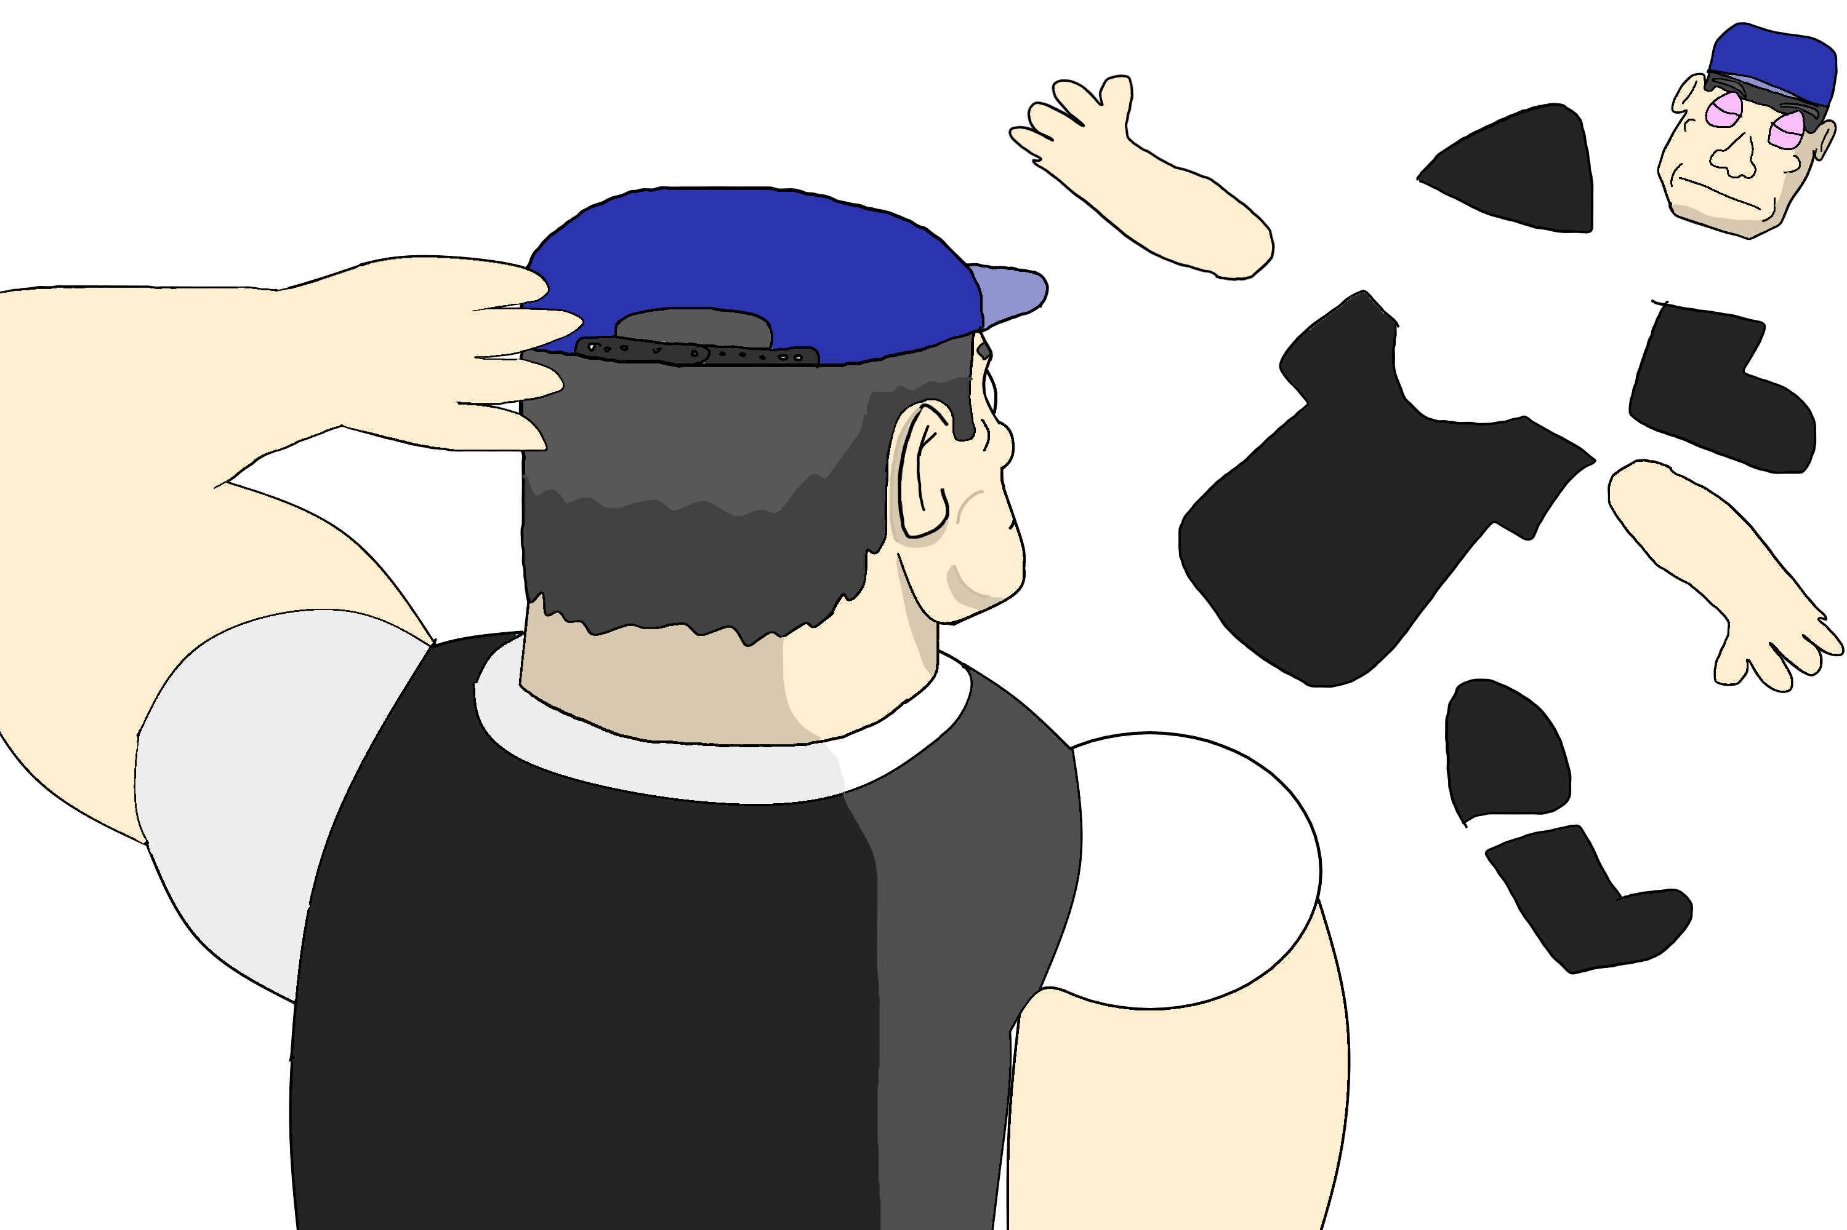

Timespan: 0:55 – 1:00

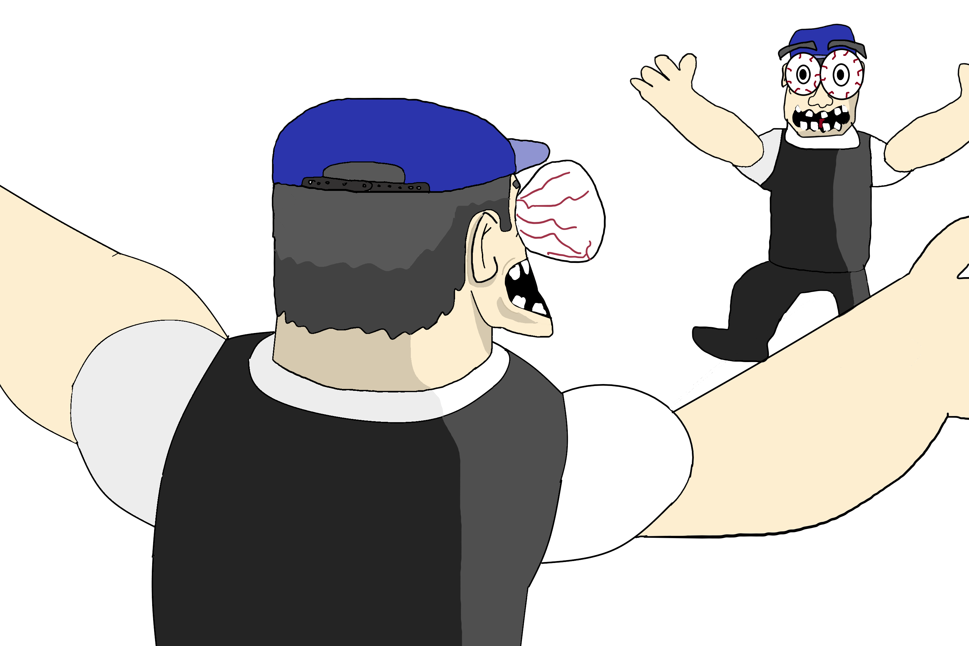

Sound/Script: climax of music ends showing a loud crumbling noise of the building fully collapsing with sound effects

Action: transition to the Main Object failing and the building collapsing with a caption saying everyone loses

Timespan: 0:45 – 0:50

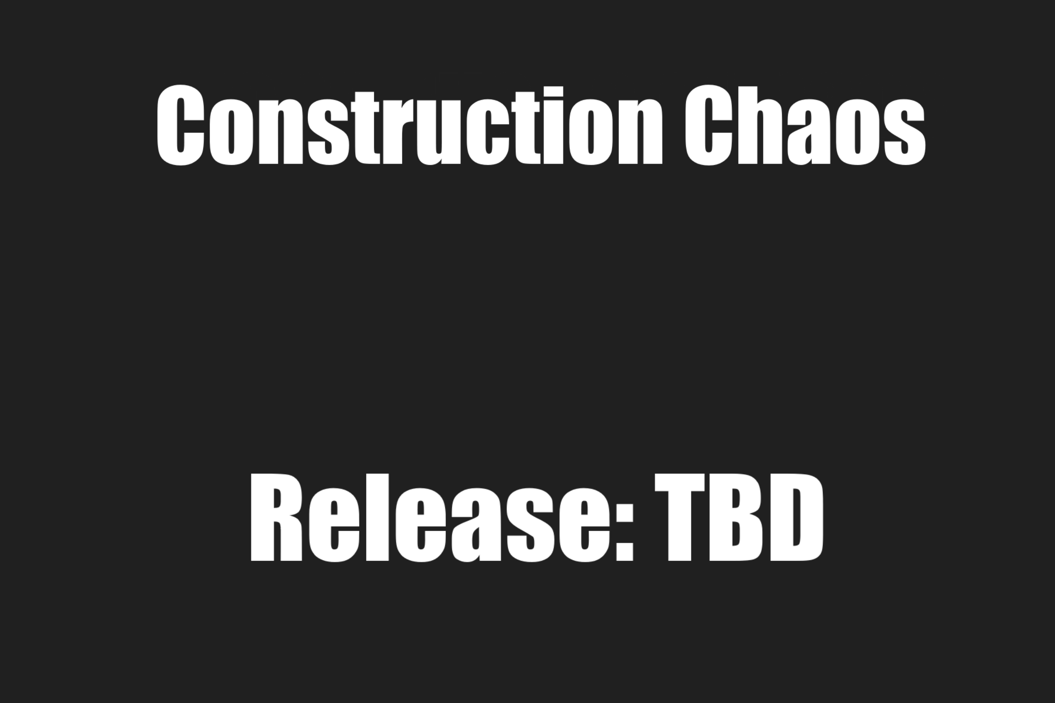

Action: transition to explain how every one does the main objective or ...

Sound/Script: Continued music reaches climax

Sound/Script: Continued music builds up slowly

Action: continued gameplay with captions explaining How your complete tasks to get points

Timespan: 0:30 – 0:35

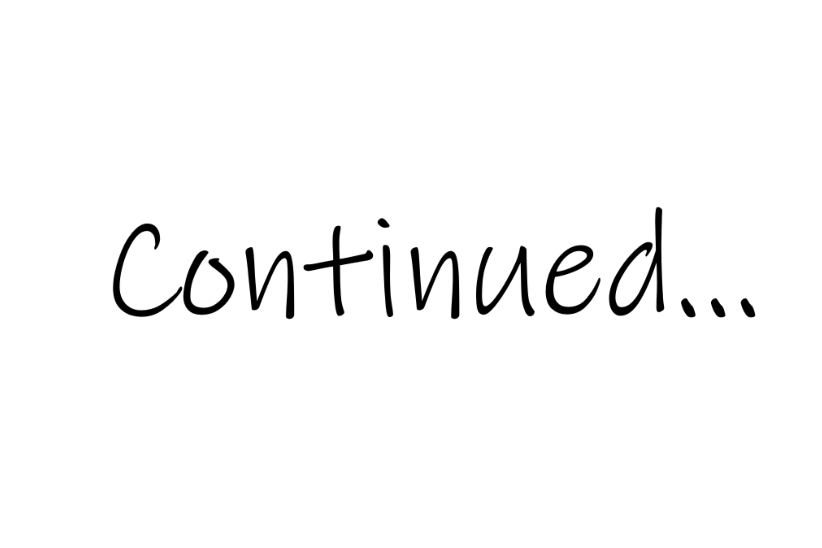

Timespan: 0:40 – 0:45

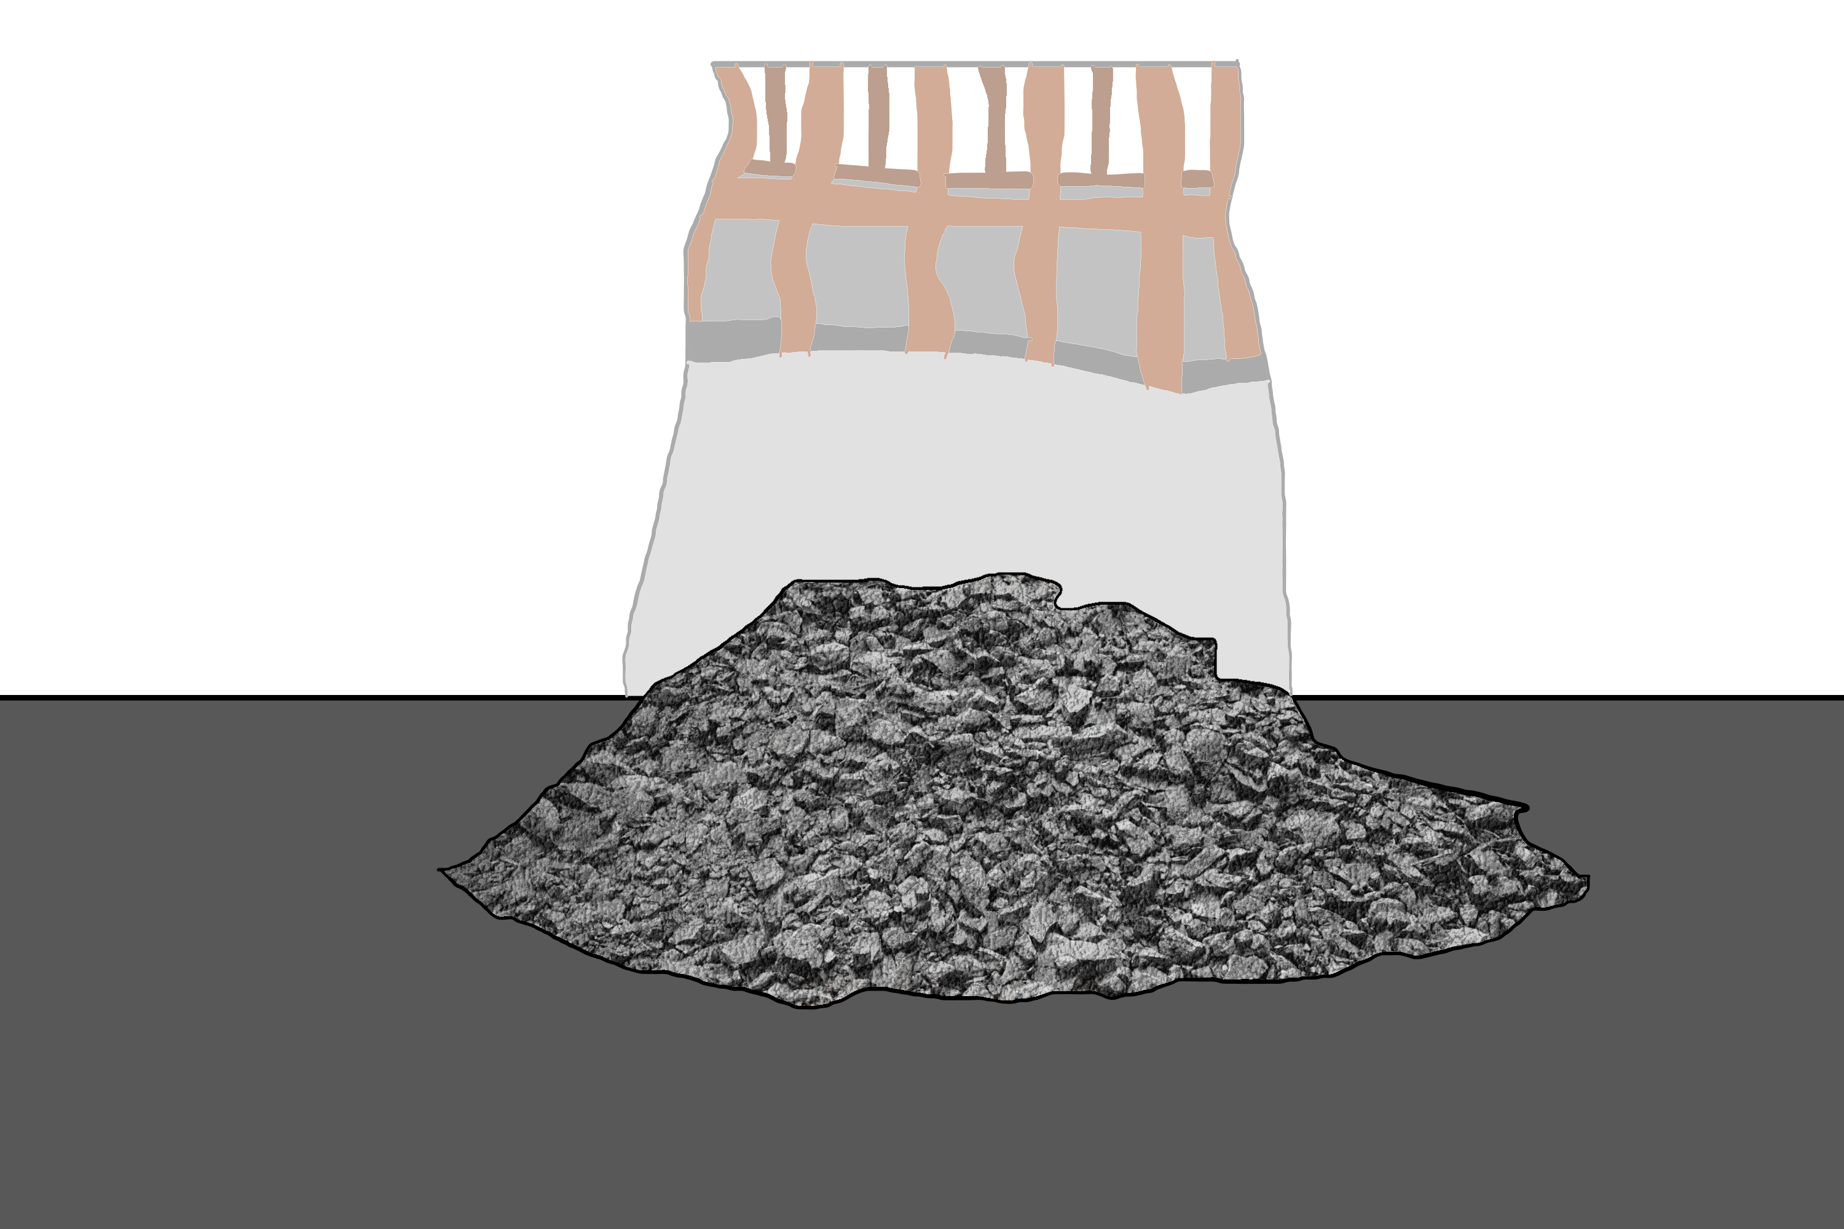

Timespan: 0:35 – 0:40

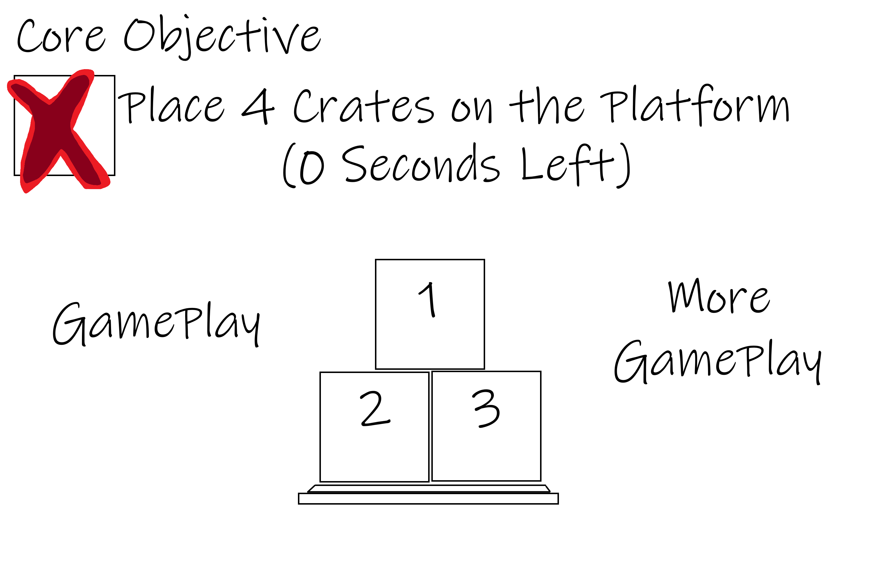

***Estimated Length: 1 Minute to 1 ¼ minutes***

***Storyboard***